# OOP Lab 4 Outputs

Name: Saahil Ghulam Mohammad

Roll Number: 24K-0570

Section: BCS-2D

Q1: 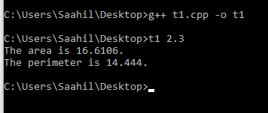

Q5: 